Program 4

Historical data records are fun to look at.

I found one that has records by city for 2016.

Download weather.csv from here:

[**https://corgis-edu.github.io/corgis/csv/weather/**](https://corgis-edu.github.io/corgis/csv/weather/)

You are to write me a report of **a particular city of your choosing**.

Your report will include three plots. I want to see:

* A histogram for **weekly** rainfall amounts
* A scatter plot showing any possible connection between avg temperature and rainfall
* A bar plot for **monthly** rainfall amounts throughout the year

You must title your plots and label the axes accordingly.

***For each plot, write a few sentences explaining “what you infer” or “what you can see” from the data.***

Lastly, I want you to output a data frame showing the total monthly rainfall for your city.

**Hints**:

* You can clear a plot with

**plt.clf()**

* You can group months using **groupby**

https://pandas.pydata.org/docs/reference/api/pandas.DataFrame.groupby.html

* If you need to get the row names of a data frame, use **dataframe.index**

**You must submit:**

* Your code (PY file)
* Your report (Word document)
* Your generated CSV file

# Sample Plots

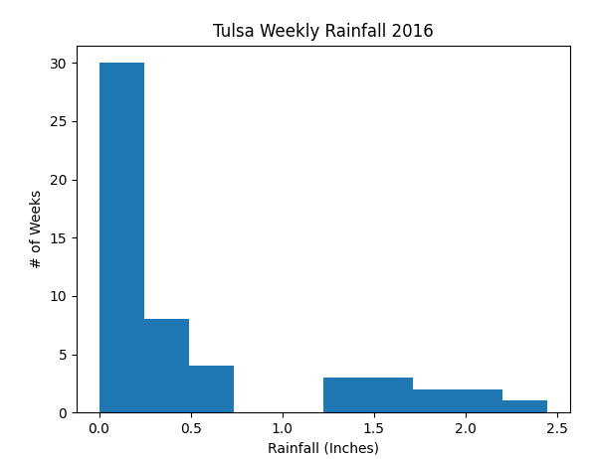

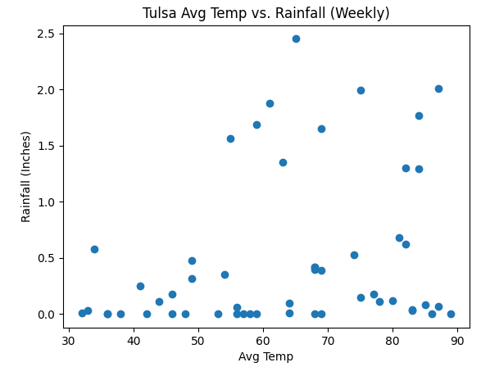

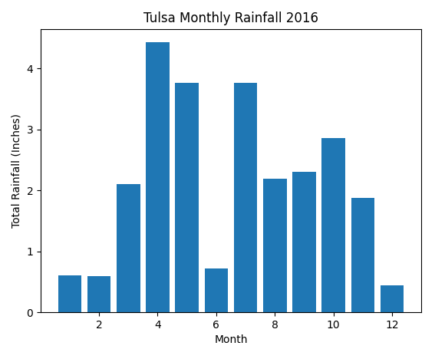

# Sample CSV file

